**Technical indicators**

**2. Exponential Moving Averages (EMA):**

* **EMA_12 and EMA_26**:   
  - These are similar to SMAs but give more weight to recent prices, making them more responsive to new information.   
  - The 12-day EMA reacts faster to price changes than the 26-day EMA.
* **EMA_50**: This is a 50-day EMA, providing insight into medium-term price trends.

**3. Moving Average Convergence Divergence (MACD):**

* **MACD Line**: Calculated by subtracting the 26-day EMA from the 12-day EMA. It shows the relationship between short-term and long-term price movements.
* **Signal Line**: A 9-day EMA of the MACD Line. When the MACD Line crosses above this line, it may indicate a potential buy signal; crossing below could suggest a sell signal.
* **Histogram**: Represents the difference between the MACD Line and the Signal Line, helping visualize the strength of the trend.

**4. Relative Strength Index (RSI):**

* **RSI**: A momentum oscillator that measures the speed and change of price movements on a scale from 0 to 100. Values above 70 may indicate that the stock is overbought (potentially overvalued), while values below 30 may suggest it's oversold (potentially undervalued).

**5. Bollinger Bands:**

* **SMA_20**: A 20-day simple moving average, serving as the middle band.
* **Upper Band and Lower Band**: These are set typically two standard deviations above and below the SMA_20, respectively. They adjust based on market volatility, expanding during volatile periods and contracting during calmer times.

**6. Stochastic Oscillator Components:**

* **L14 and H14**: The lowest and highest prices over the past 14 days, respectively.
* **%K**: Shows the current closing price's position relative to the recent high-low range, indicating momentum.
* **%D**: A 3-day moving average of %K, used to identify potential buy or sell signals when it crosses %K.

**Version 2 :**   
  
  
  
**Trend - Following Indicators:** Identify the direction and strength of market trends.

* *Examples:* Moving Averages (SMA, **EMA**), Moving Average Convergence Divergence (MACD).
* **Exponential Moving Average (EMA):** Utilize the 50-day EMA to identify the prevailing market trend, as it responds more swiftly to recent price changes compared to the Simple Moving Average (SMA)  
    
  .
* **Moving Average Convergence Divergence (MACD):** Captures the relationship between short-term and long-term price movements  
    
  **Components**:
* **MACD Line**: Calculated by subtracting the 26-day EMA from the 12-day EMA.
* **Signal Line**: A 9-day EMA of the MACD Line.

**Why Include It**:

* **Trend Identification**: Highlights changes in momentum and potential trend reversals.
* **Redundancy Avoidance**: Incorporates EMAs within its calculation, reducing the need to include EMA_12 and EMA_26 separately.

-(SMA), EMA?

**Momentum Indicators:** Measure the speed of price movements to detect overbought or oversold conditions.

* *Examples:* Relative Strength Index (**RSI**): Measures the speed and magnitude of price movements.  
    
  **Why Include It**:
* **Momentum Indicator**: Helps identify overbought (above 70) or oversold (below 30) conditions.
* **Unique Insight**: Provides different momentum analysis compared to MACD.

Offers insights into momentum and potential reversal points by indicating overbought or oversold conditions.  
  
  
-(Stochastic Oscillator)

**Volatility Indicators:** Assess the rate of price fluctuations over time.

* **Bollinger Bands**: Assesses market volatility and potential price extremes.
* Consist of a 20-day SMA (middle band) with upper and lower bands set typically two standard deviations away. They adjust based on market volatility, expanding during volatile periods and contracting during calmer times.
* Help assess price volatility and potential price extremes, indicating possible overbought or oversold conditions
* -(Average True Range (ATR))

**Volume Indicators:** Analyze trading volume to confirm price trends and strength.

* On-Balance Volume (**OBV**) : Combines price and volume data to show how volume is flowing into or out of a security, helping to confirm price trends.  
  - Assists in confirming price trends through volume analysis, indicating the strength of a price movement.  
    
    
    
  -(Money Flow Index (MFI))

**To Avoiding Redundancy**:

* **MACD** covers trend and momentum aspects that might overlap with EMAs.
* **RSI** and **Stochastic Oscillator** both measure momentum; including only **RSI** reduces overlap.
* **Bollinger Bands** provide volatility insights without needing multiple volatility indicators.

Rsi based MA ?  
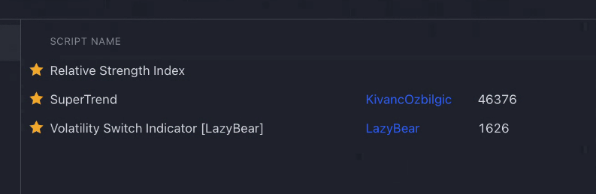

References:

GDP and UNRATE dataset link:

https://fred.stlouisfed.org/series/UNRATE